* for the trade press * for the trade press * for the trade press * for the trade press *

www.rosenberger.com Fridolfing, January 2023

HSI Connectors – an Innovative System for All-Terrain-Applications

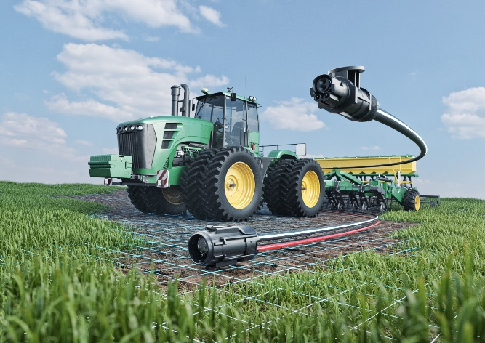
For reliable high-speed data and power transmission in harsh environments, Rosenberger has developed the HSI connector system. Designed for demanding outdoor conditions and standardized in cooperation with the AEF (Agricultural Industry Electronics Foundation), HSI - High-Speed Implement Bus System - is the new standard. For applications in trucks to construction machinery to agricultural applications, HSI connectors are true all-rounders.

High-performance and robust connections between tractors and trailers or seed, fertilizer and harvesting machines are indispensable for reliable high-speed data transmission - an increasingly important component in the electronics of vehicles and machines.
HSI connectors also impress with their robustness and electrical reliability in other all-terrain applications under demanding environmental conditions, such as in the construction vehicle industry.

Applications of HSI interconnect systems include monitoring systems, data systems for consumption, seed and fertilizer optimization, GPS coordination, and level and tonnage measurement.

The extremely rugged HSI connector system features highly reliable power and data transmission, break-away connection, waterproofing and UV resistance.

Detailed information can be found on our website:
New HSI Connector System – The All-Terrain Innovation - Rosenberger Group

About Rosenberger
Rosenberger is one of the world’s leading manufacturers of impedance-controlled and optical interconnect solutions in high-frequency, high-voltage and fibre-optic technology.

The product range covers RF coaxial connectors, components and accessories, RF measurement products as well as cable assemblies for mobile communication networks, data centres, industrial test & measurement, automotive electronics as well as for high-voltage contact systems, medical and industrial electronics as well as aerospace engineering. The Custom machining division manufactures customer-specific precision parts from all machinable materials for various industries such as the automotive and commercial vehicle industry, ship building or classic mechanical and plant engineering.

Worldwide, the Rosenberger Group operates manufacturing and assembly locations as well as Rosenberger sales offices in Europe, Asia and North and South America where – in total – more than 15,000 employees develop, produce and sell our products. Rosenberger Hochfrequenztechnik GmbH & Co. KG with its headquarters in Fridolfing/Germany, where approx. 3,000 people are employed today, was founded in 1958 and has been family-owned ever since.

Contact:
Fritz Herrmann
Marketing Services

Phone +49 (0)8684 18-1263
fritz.herrmann@rosenberger.com

